TASK-1
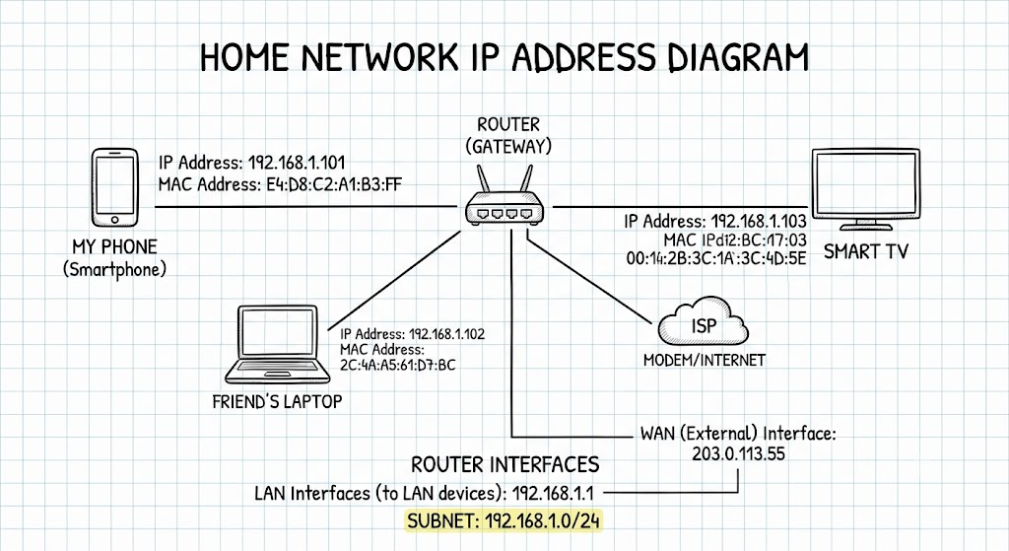

TASK-2
Your simulation is well structured. Here's a cleaner, assignment-ready version with a simple routing summary table at the end.

IP Packet Journey Across Two Routers
1. Network Setup & Topology
- Your Laptop (Source): 192.168.1.10/24
- Router 1 (R1)
  - LAN: 192.168.1.1
  - WAN: 10.0.0.1/30
- Router 2 (R2)
  - WAN: 10.0.0.2/30
  - LAN: 192.168.2.1

Friend's Laptop (Destination): 192.168.2.50/24
LAN WAN LAN

+-------------+ +------------+ +------------+ +-------------+
| Your Laptop |----->| Router 1 |=====>| Router 2 |----->| Friend's PC |
|192.168.1.10 | |192.168.1.1 | |10.0.0.2 | |192.168.2.50 |
+-------------+ |10.0.0.1 | |192.168.2.1 | +-------------+
+------------+ +------------+

Step 1: Source Laptop
- The laptop wants to send data to 192.168.2.50.
- It compares the destination with its subnet (192.168.1.0/24).
- Since the destination is in a different subnet, it sends the packet to the default gateway (192.168.1.1).
- The packet is placed inside an Ethernet frame and sent to Router 1.

Step 2: Router 1 (R1)
- R1 removes the Ethernet header and checks the destination IP.
- It looks up its routing table.
- It finds that network 192.168.2.0/24 is reachable through 10.0.0.2.
- R1 decreases the TTL by 1.
- The packet is encapsulated in a new frame and forwarded through the WAN to Router 2.

Step 3: Router 2 (R2)
- Router 2 receives the packet on its WAN interface.
- It checks its routing table.
- The destination network 192.168.2.0/24 is directly connected.
- R2 performs an ARP request (if necessary) to obtain the MAC address of 192.168.2.50.
- The TTL is decreased by 1.
- The packet is sent onto the local LAN.

Step 4: Destination Laptop
- The friend's laptop receives the Ethernet frame.
- It verifies that the destination IP is 192.168.2.50.
- The Ethernet and IP headers are removed.
- The data is delivered to the correct application (such as Ping, File Sharing, or a Web Browser).

Routing Summary
Device | Source IP | Destination IP | Next Hop | Outgoing Interface
Your Laptop | 192.168.1.10 | 192.168.2.50 | 192.168.1.1 | eth0
Router 1 | 192.168.1.10 | 192.168.2.50 | 10.0.0.2 | eth1
Router 2 | 192.168.1.10 | 192.168.2.50 | Directly Connected | eth0
Friend's Laptop | 192.168.1.10 | 192.168.2.50 | Packet Received | NIC
Conclusion
The IP packet travels from the source laptop to Router 1, then to Router 2, and finally reaches the friend's laptop. At each router, the routing table is checked, the TTL is reduced by one, and a new Layer 2 frame is created for the next hop until the packet reaches its destination.

TASK-3

Routing Table for a Zomato-Style Delivery Network
Branch (City) | Network Address | Subnet Mask | Next Hop | Interface
Ahmedabad Branch | 192.168.10.0 | 255.255.255.0 | 10.0.0.2 | eth0
Surat Branch | 192.168.20.0 | 255.255.255.0 | 10.0.0.6 | eth1
Vadodara Branch | 192.168.30.0 | 255.255.255.0 | 10.0.0.10 | eth2

Network Diagram
Zomato Head Office Router
|
---------------------------------------------
| | |
eth0 eth1 eth2
| | |
10.0.0.2 10.0.0.6 10.0.0.10
| | |
Ahmedabad Surat Vadodara
192.168.10.0/24 192.168.20.0/24 192.168.30.0/24
Explanation
- Ahmedabad Branch: Uses subnet 192.168.10.0/24 and is reached through 10.0.0.2 via eth0.
- Surat Branch: Uses subnet 192.168.20.0/24 and is reached through 10.0.0.6 via eth1.
- Vadodara Branch: Uses subnet 192.168.30.0/24 and is reached through 10.0.0.10 via eth2.
This routing table allows the head office router to forward delivery and order data to the correct city branch efficiently.

TASK -4

Routing Type | Pros (3) | Cons (3) | Real-World Example
Static Routing | 1. Simple to configure.2. Low CPU and bandwidth usage.3. More secure (no routing updates). | 1. Manual configuration required.2. Not suitable for large networks.3. Does not automatically adapt to network failures. | Small office or a small restaurant using Zomato POS with a simple network.
Dynamic Routing (RIP/OSPF) | 1. Automatically updates routes.2. Scales well for large networks.3. Automatically finds alternate paths if a link fails. | 1. More complex to configure.2. Uses CPU and bandwidth for routing updates.3. Requires more memory and processing power. | Zomato, Google Maps, or YouTube data centers use dynamic routing to keep services fast and available even if a network path fails.

TASK-5
Sample OSPF Configuration Between Two Routers (Cisco IOS)
Router 1 (R1)
enable
configure terminal
router ospf 1
network 192.168.1.0 0.0.0.255 area 0
network 10.0.0.0 0.0.0.3 area 0
end
write memory
Router 2 (R2)
enable
configure terminal
router ospf 1
network 192.168.2.0 0.0.0.255 area 0
network 10.0.0.0 0.0.0.3 area 0
end
write memory

Explanation of Each Configuration Line
Configuration Line | Description
enable | Enters privileged EXEC mode.
configure terminal | Enters global configuration mode.
router ospf 1 | Starts the OSPF routing process with Process ID 1.
network 192.168.1.0 0.0.0.255 area 0 | Enables OSPF for the 192.168.1.0/24 network and places it in Area 0.
network 192.168.2.0 0.0.0.255 area 0 | Enables OSPF for the 192.168.2.0/24 network on Router 2.
network 10.0.0.0 0.0.0.3 area 0 | Enables OSPF on the link connecting the two routers (10.0.0.0/30).
end | Exits configuration mode.
write memory | Saves the configuration so it remains after a restart.

In My Own Words
- enable gives administrator access to the router.
- configure terminal allows me to change the router's settings.
- router ospf 1 turns on the OSPF routing protocol.
- The network commands tell OSPF which networks should be advertised to other routers.
- area 0 places the networks in the OSPF backbone area.
- end exits configuration mode.
- write memory saves the configuration permanently.

